Jennifer E. Siegler

**Lilanga**, George (1934-2005)

George Lilanga of Tanzania was at one time considered the most prominent contemporary African artist. Best known for his colorful paintings and sculptures of ‘mashetani,’ or devils in Kiswahili, Lilanga transformed a Makonde art form developed in the 1950s into an international brand. Although his works have been exhibited widely in the United States, Europe, and Japan since the late 1970s, he received little recognition in Tanzania until the 21st Century, over twenty years after he first garnered international attention. Lilanga’s diverse work is unified by playful ‘mashetani,’ performing scenes of daily life in villages and cities in Tanzania. The spirits are typically depicted as a hairless creature with large ears, a wide-open mouth, prominent teeth, and a protruding stomach. Their hands only have two fingers, and their feet have three toes. Mashetani inhabiting village scenes are often depicted bare-chested with a wrap around their waist, while those in urban scenes are shown wearing Western clothing. Lilanga’s style is characterised by a sinuous line and bright, saturated hues. His two-dimensional works feature forms outlined in black or white. His compositions have no horizon line, and rarely include any form of environmental details. Lilanga’s themes are often commentary on changing societal values, with his titles providing aphorisms encouraging traditional morals.

George Lilanga of the Makonde was born in 1934 in Kikwetu Village in Southern Tanzania, near the Mozambique border. He received traditional Makonde initiation education in woodcarving that began with carving cassava, then soft wood, and finally ebony (mpingo). After this, he worked on a sisal plantation while still carving to supplement his income. His first works that deviated from traditional Makonde carvings found patronage from European visitors to the Lutamba Refugee Camp. In 1974, he moved to Dar es Salaam where carving was more lucrative, and became involved with the Nyumba ya Sanaa, or House of Art. There, he transitioned away from carving and began drawing, painting on goat skins, and etching. His most recognisable work from this period is the painted metal entrance gate to the Nyumba ya Sanaa.

Lilanga’s first international success occurred in 1978, with a group exhibition in Washington DC featuring one hundred of his works. This began a period of international gallery exhibits that has continued posthumously. Critical acclaim compared Lilanga to Keith Haring, and Haring later acknowledged the influence of Lilanga’s artistry on his own work.

During the 1970s, Lilanga collaborated with Edward Saidi Tingatinga, another internationally prominent Tanzanian painter of the time, most visible in Lilanga’s adoption of the 60x60 cm square canvases that Tingatinga popularised. In the late 1990s, Lilanga moved to large format canvases and hardboard plates, and sculpture again featured more prominently in his production. In 2005, Lilanga died of complications from diabetes.

**References and Further Reading**

Lilanga, G. and Goscinny, Y. (2001), *Tribute to George Lilanga : a solo-exhibition of George Lilanga's recent paintings and sculptures at the Alliance Français of Dar es Salaam, Tanzania (September 18-October 6, 2001).* Dar es Salaam : East African Movies Ltd.

Lilanga, G and Kamphausen P-A. (2005), *George Lilanga : rangi ya maisha = Farben des Lebens = colours of life.* Hamburg, Germany: Hamburg Mawingu Collection.

Lilanga, G and Mascelloni E. (2005), *George Lilanga.* Milano: Skira.

Lilanga, G. and Pippi, C. (2007), *George Lilanga : colori d'Africa : opere scelte, 1971-2005 / a cura di Cesare Pippi = George Lilanga : colours of Africa : selected works, 1971-2005 / curated by Cesare Pippi.* San Sisto (Perugia): Effe.

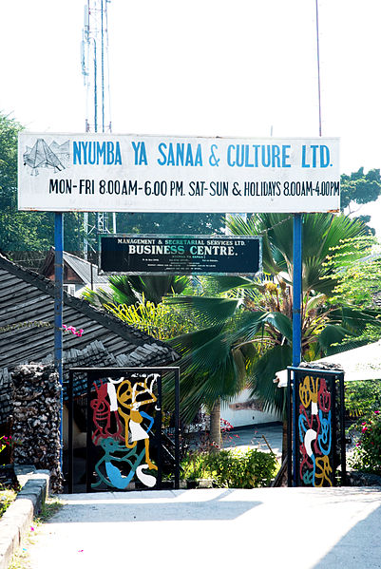

<http://upload.wikimedia.org/wikipedia/commons/6/61/Nyumba_ya_sanaa_dar_es_salaam.jpg>

Gates to Nyumba ya Sanaa, 1974

Enamel on metal

Dar es Salaam, Tanzania